**Graphing Details Information**

|  |  |  |  |  |  |
| --- | --- | --- | --- | --- | --- |
| Volume (cm3­) ± 2 cm3 | 10. | 20. | 30. | 40. | 50. |
| Mass (g)± 0.5 g | 7.2 | 12.8 | 21.0 | 25.7 | 35.2 |

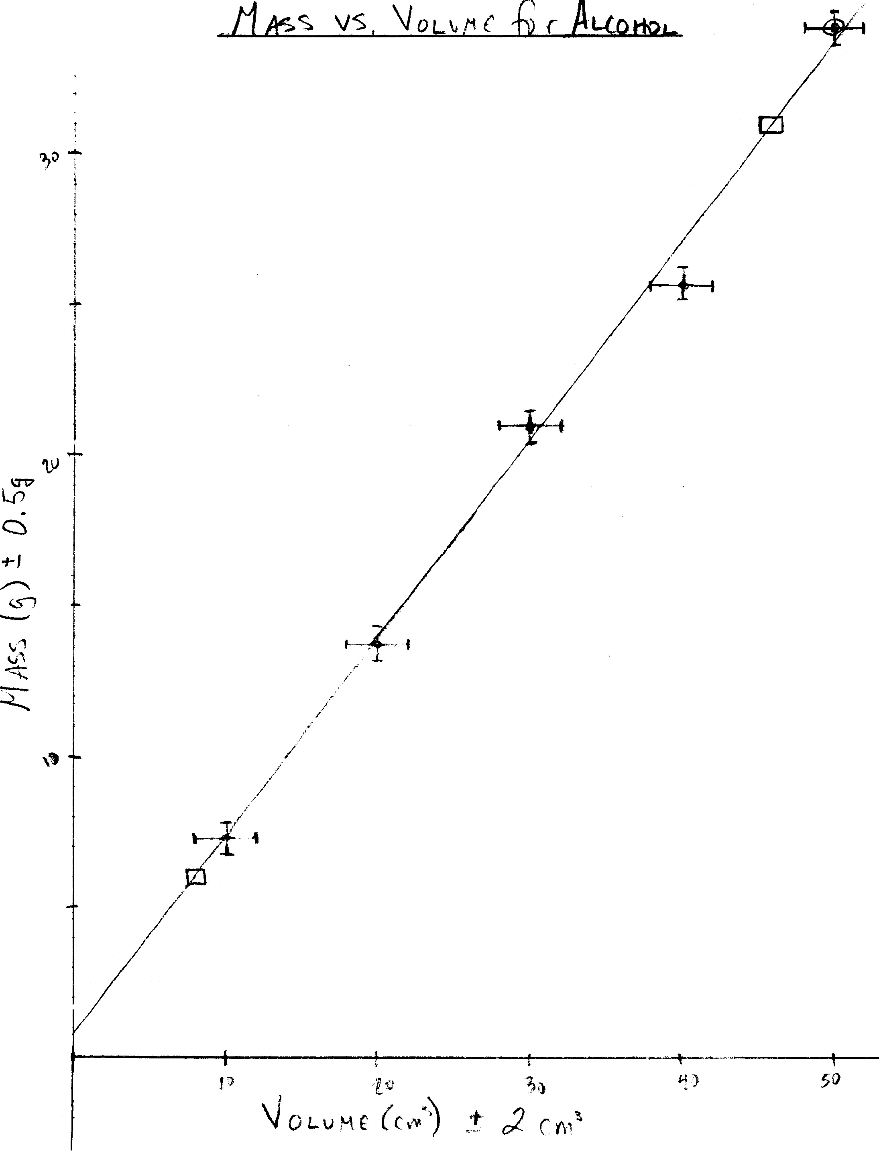

1. Use a clean sheet of graph paper, a ruler, and a sharp pencil and plan your graph to take up most of the page.
2. Label each axis with a variable name, symbol, and units, for example **Volume (V) (cm3)**. Usually, the independent variable is graphed on the x-axis, though there are often times and reasons for graphing it on the y-axis, such as, if it better matches your math model this way.
3. Choose an appropriate scale for each axis. Usually you should begin the graph at (0, 0). (On a **very rare** occasion, you may need a “break” in the graph where you skip to higher values. Avoid doing this if at all possible.) Space out the units appropriately and evenly. The value of the spacing does not have to be the same on each axis.
4. Title your graph: *Dependent vs. Independent* For example: *Mass vs. Volume for a Sample of Alcohol*
5. Plot your points carefully – make the dot large enough to see.
6. Should you put a data point at (0,0)? If it was not one of the measured data points, you will have to make a judgment as to whether or not it should be included as part of your graphed data.
7. Include ***error bars*** drawn to scale for each data point in at least one direction (x or y). Choose the most significant error bars (proportionally largest) to draw.

9. Consider any *outlier*. This is a point where the best-fit line doesn’t go through the error bars. Maybe you made some mistake when taking this data point. You will have to explain why it’s an outlier in your lab evaluation. If you have too many outliers, maybe the shape isn’t really linear.

10. If it looks like some other relationship (quadratic, inverse, etc.), draw in that ***best-fit curve*** smoothly by hand. (Sometimes even a curve is called a best-fit “line.”)

11. If it’s a straight line, calculate the ***slope*** *(gradient)* of the line. Use two points **on** the line - these may or may not be data points. Put a box around each point used, state their actual coordinates (don’t count boxes) and show your calculations, including formula and substitutions. Express the result as a decimal to the appropriate number of significant digits and include units. For example:

1. Do not play “connect-the-dots” with your data points. Look at the general shape made by your data points and decide what relationship it looks like. If it looks linear, draw in with a ruler a ***best-fit line*** (regression line) that fits within all or most of your error bars. Try to have as many points above the best-fit line as below it.
2. Consider any *outlier*. This is a point where the best-fit line doesn’t go through the error bars. Maybe you made some mistake when taking this data point. You will have to explain why it’s an outlier in your lab evaluation. If you have too many outliers, maybe the shape isn’t really linear.

10. If it looks like some other relationship (quadratic, inverse, etc.), draw in that ***best-fit curve*** smoothly by hand. (Sometimes even a curve is called a best-fit “line.”)

11. If it’s a straight line, calculate the ***slope*** *(gradient)* of the line. Use two points **on** the line - these may or may not be data points. Put a box around each point used, state their actual coordinates (don’t count boxes) and show your calculations, including formula and substitutions. Express the result as a decimal to the appropriate number of significant digits and include units. For example:



12. Write the ***experimental relationship*** for the line you’ve drawn by filling in the specific symbols for your data and the slope and y-intercept into the general equation for a line.



*Experimental Relationship:*

M = (0.66 g/cm3)V + 0.8 g

*General Equation:*

y = mx + b

13. Consider the physical significance of the slope and/or the y-intercept. Does it have a meaning or a special name? Compare your equation to a known ***mathematical model*** in order to draw conclusions.



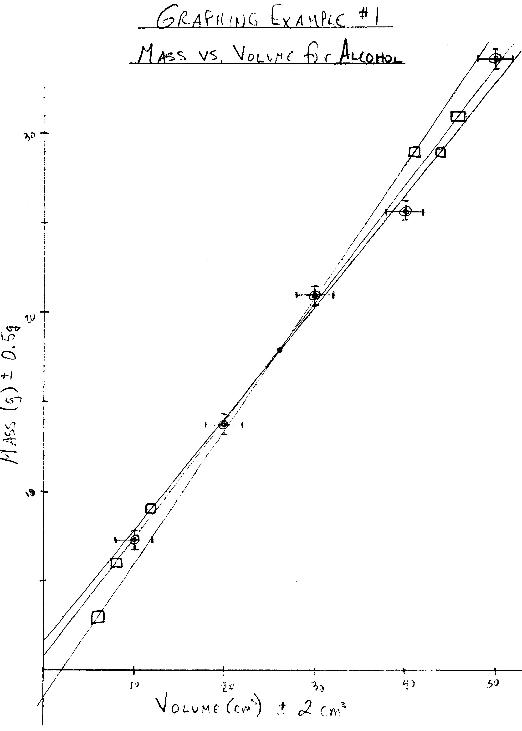

*Maximum slope:* 0.74 g/cm3

*Best-fit slope:* 0.66 g/cm3

*Minimum slope:* 0.63 g/cm3

*Range:* 0.74 g/cm3 – 0.63 g/cm3 = 0.11 g/cm3

*Uncertainty:* ½(0.11 g/cm3) = 0.055 g/cm3 = 0.06 g/cm3

***Slope with uncertainty:* 0.66 g/cm3 ± 0.06 g/cm3**

15. Determine the slopes of your max and min lines. You do not need to show these calculations. Calculate the range of your slopes (max slope – min slope) and use ½ the range as the uncertainty for the slope of your best-fit line. Round the uncertainty to one sig fig and be sure to match the decimal place between the best-fit slope and its uncertainty. (You may need to round the best-fit slope to do this.)

14. Draw the line of maximum slope that fits your error bars and the line of minimum slope that fits your error bars. These are called your *max/min lines****.*** All three lines (best-fit, max, min) should cross at or near the midpoint of your data. The quickest and easiest way to do this is to connect the top(left) of the first error bar to the bottom(right) of the last error bar (for a minimum line) and the bottom(right) of the first error bar to the top(left) of the last error bar (for a maximum line) unless the first or last points are clear outliers – use your judgment.

**Conclusion**:

*By comparing the experimental equation to the mathematical model, the slope represents the density of the liquid so the alcohol’s density is 0.66 g/cm3.*

*Mathematical Model:*

17. Does the mathematical model predict that the y-intercept should be zero? If so, see if your results agree with this by inspecting the graph to see if (0, 0) falls within the max and min lines you drew. If (0, 0) does **not** fall within the uncertainty range, you probably have a systematic error in your experiment that you will now have to account for.

16. If there is a physical significance for your slope and if there is a known literature value for this quantity, then decide if your results “agree with” the literature value by considering the uncertainty range.

**Conclusion:**

*The literature value for the density of ethyl alcohol is 0.71 g/cm3. Our results agree with the literature value since 0.73 g/cm3 lies within the uncertainty range of 0.66 g/cm3 ± 0.06 g/cm3.*